Copyright© CleanSync Team. All rights reserved
CleanSync User Guide
Version 2.0
Presented by Team 0110
2010/4/15

1. About CleanSync 2
1.1 Overview 2
1.2 Clean Synchronization 3
1.3 CleanSync Features 4
2. How to use 6
2.1 Installation CleanSync 6
2.2 Starting CleanSync 6
2.3 Creating a new CleanSync Job 7
2.4 Accepting a CleanSync Job 12
2.5 Synchronizing a job 15
2.6 Conflicts 18
2.7 Deleting a job 19
3. About us 20

About CleanSync

Overview

Frequently need to work on the same files and folders on 2 different computers? Having trouble ensuring both sets of files and folders are updated? Let CleanSync handle that for you!

Consider this scenario: You have to ensure that files and folders in a certain directory are the same in Computer A and Computer B. Each time, you will need to copy all the files from one side to other side by copying and pasting every single files (or only changed files, which might take longer to find out).

Clean Synchronization

So, how does CleanSync work? CleanSync does synchronization through a process called Clean Synchronization. Through Clean Synchronization, synchronizing folders between Computer A and B is done in 2 easy steps:
Step 1: Synchronize on your first PC (Computer A). Assuming that Computer A has one new file (File3.txt), a modified file (File5.txt) and File4.txt has been deleted after the last synchronization. All these information will be acknowledged by the external drive.

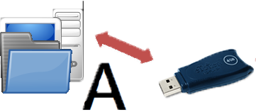
PC A:
File1.txt
File2.txt
File3.txt -- Detected new file
File5.txt -- Detected to be modified
File6.txt
Detected File4.txt has been deleted.
Copied to USB:
File3.txt (New file)
File5.txt (Modified file)
File4.txt (Deleted file)
Step 2: Unplug external device from Computer A, plug into and synchronize with your second PC (Computer B). CleanSync will copy File3.txt, modify File5.txt over to Computer B and delete File4.txt. It will also repeat Step 1 on Computer B, to synchronize Computer B’s updates to Computer A.
USB:
File3.txt (New file)
File5.txt (Modified file)
File4.txt (Deleted file)
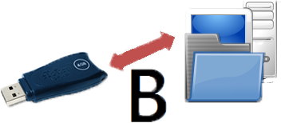
Update to PC B:
Create File3.txt
Modify File5.txt
Delete File4.txt

CleanSync Features
 Clean Synchronization
Utilizing clean synchronization, you can synchronize between two computers via a removable storage device. Unlike ordinary synchronization which just synchronize two folders local to the computer, Clean Synchronization is designed to synchronize two folders on different computers without using a fully synchronized folder copy on the removable storage device. Only files that are required to be updated will be stored on the removable storage device, keeping disk usage low.
 Safe Synchronization
CleanSync is designed to prevent unwanted loss of important files and folders. If the removable drive is accidentally removed, or if the computer shuts down during synchronization, CleanSync will restore everything to the state before synchronization.
 Cleaner Folders
CleanSync will not pollute your folders on computer with extra data.
 Automated Removable storage device Detection
Removable device is an important intermediary storage device. CleanSync automatically detects the plug-in and plug-out of removable devices(flash drive or external hard disk), and will also automatically resolve the changes in disk letter. These enable user to focus on the folders on computer they intended to synchronize without bothering about the intermediary device.
 Automation Support
With the option to synchronize automatically when plugged in, you need not even click a bottom.
 Clean and intuitive user interface
CleanSync is designed to be intuitive and easy-to-use.

 Synchronization Cancellation
If you change your mind, you can cancel at anytime during synchronization.
 Folder Back-up
Files and folders deleted during the latest synchronization process will not be deleted but stored in the “CleanSync” folder in your computer’s Application Data folder

How to use

2.1 Installation CleanSync

Unzip CleanSync_v2.0.zip to any directory in your computer. A folder “CleanSync v2.0” will be created in that directory.

2.2 Starting CleanSync

To start, double click on CleanSync.exe
You are now in the main screen.
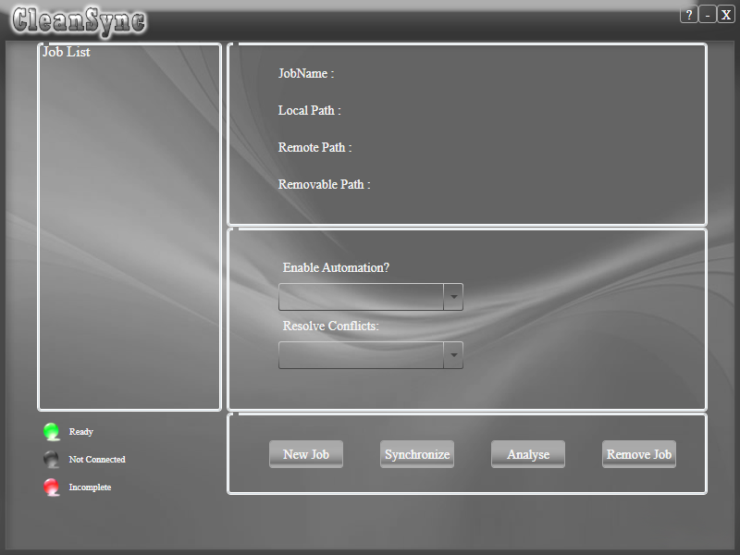

2.3 Creating a new CleanSync Job

From the main screen, click on "New Job" to create a new job.

Then you will be inside the new job window.
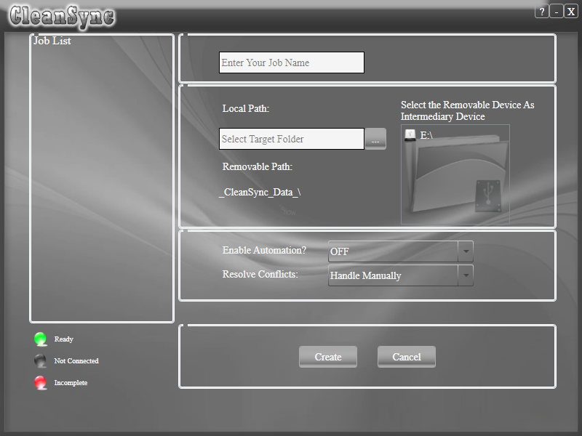

Enter a name for the job, and select the folder to synchronize.
Select a folder on the USB drive to store the data on the USB drive.
You are ready to synchronize for the first time!
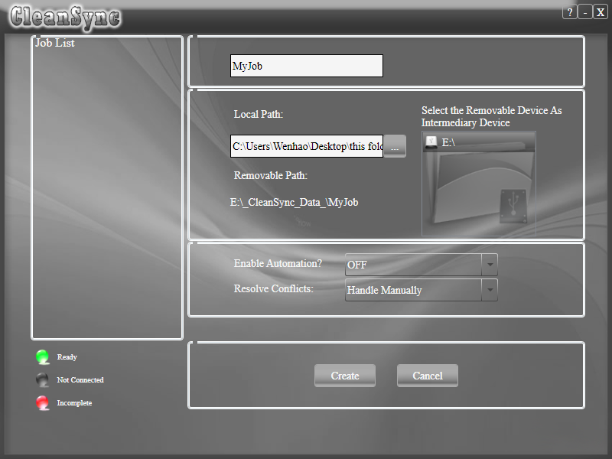
Enter the job name
Enter path on PC
Select an external drive

Click on "Create" to create job, CleanSync will copy all the files from the PC folder to the USB folder.

Creating a job on this PC is now complete!
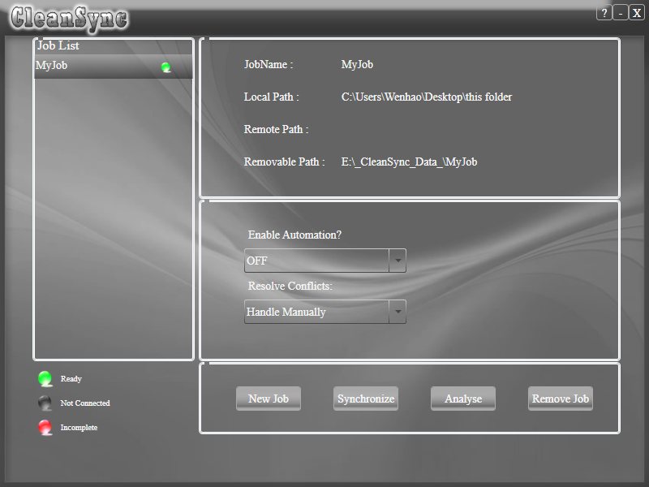

Now you can plug the removable storage device into another computer with CleanSync installed for the other computer to accept the CleanSync job.

2.4 Accepting a CleanSync Job

From the main screen, if an external drive with a job that has not been accepted is plugged in, it will be shown on the main menu and you will have the option of accepting the CleanSync job. An incomplete job will be listed with the color red.

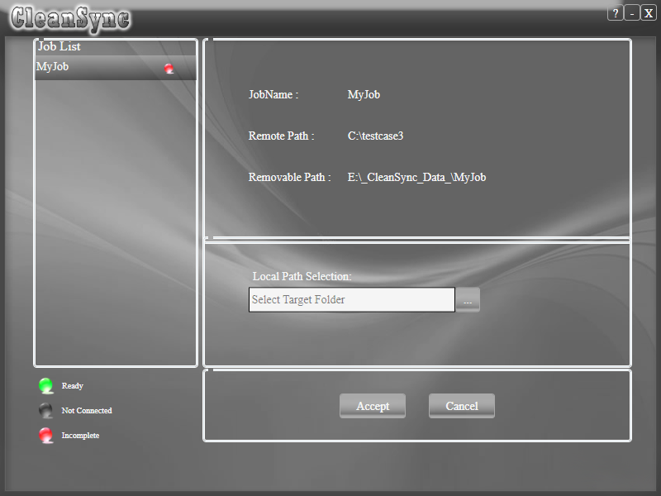

To accept, select the incomplete job, select a folder to synchronize on and click on “Accept”.

Choose path on PC

You will go back to main frame and the job now is colored green.

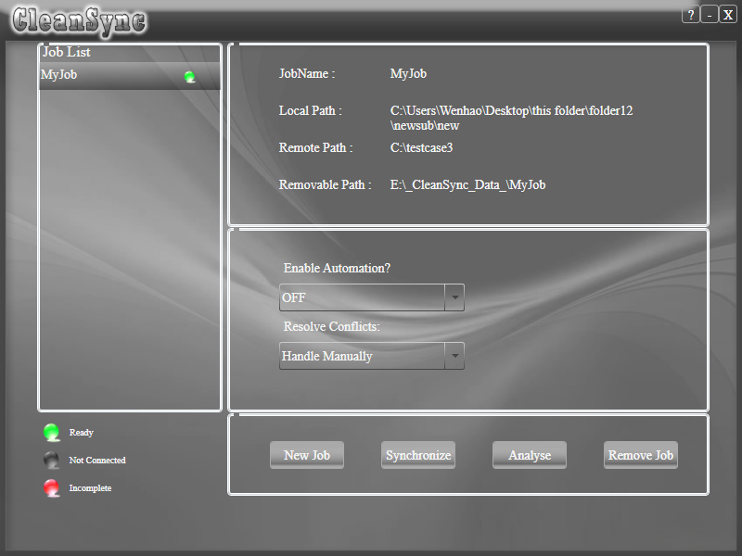

Accepting a CleanSync job is now complete!

2.5 Synchronizing a job

From the main screen, select the job you want to synchronize.
Only jobs with their USB drives plugged in are allowed to be synchronized (i.e jobs listed with the color green).
Click on “Analyse” to view the impending changes.

 denotes a new file/folder to be copied over.
 denotes a modified file or a folder whose contents have been changed.
 denotes a deleted file or folder.

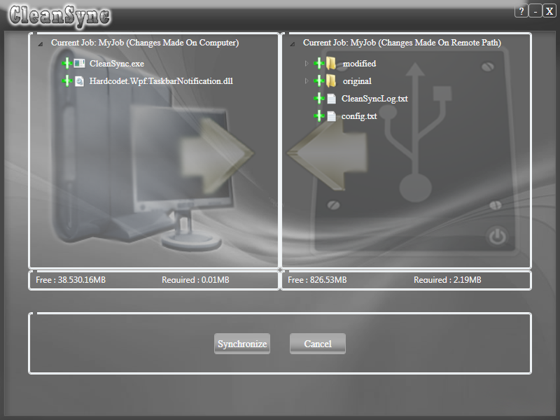

After viewing the changes that will happen from USB to PC and from PC to USB, click on “Synchronize” to start synchronization.

2.6 Conflicts

After analyzing, in the event of conflicts, i.e files to be deleted on the other PC has already been modified on this PC, a conflict window will appear.

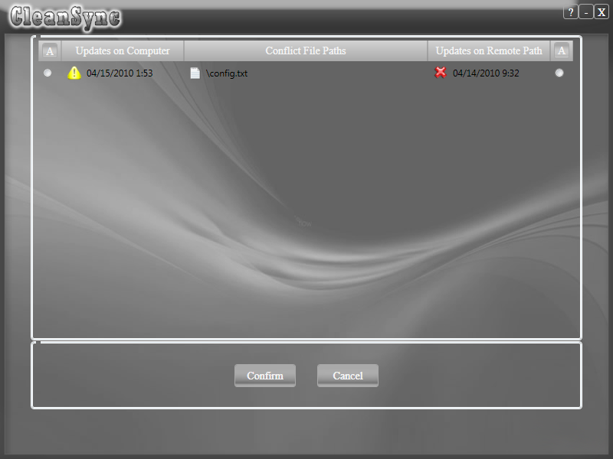

Click on either the left radio button to use the PC’s file as the latest file, or click the right radio button to keep the USB’s as the latest file. Then click “Confirm” to confirm your selection.

2.7 Deleting a job

To delete a job, select the job you want to delete and click on “Remove Job”.

If the USB device is not plugged in, the data on the USB device will be deleted the next time the USB device is plugged in. To delete the job on the other computer, just plug in the USB into the other computer.

About us

0110 is a group of 6 students from the National University of Singapore, studying in the School of Computing. CleanSync is our product and has come to be our proud and joy.

Group Leader: Li Yi
Group Members: Gu Yang
Li ZiChen
Lu Wenhao
Tso Shuk Yi
Yu Qiqi

Special thanks to Dr. Damith, our mentor for this project, Dr. Soo for CleanSync’s architecture, Mr. Jonathan Poon, Miss Maung, Mr. Xue Yinxing, Miss Yip Yoke Min Shawn and everyone who give us invaluable feedback on our product.

